BOLAND ORGANIC SOLUTIONS REPORT :

MAIZE TRIAL

Farmer: Zandraai Boerdery
Area: Hopetown
Agent: WH
Dates: 2018

AIM: To test differences in yield with the addition of HP Active (improved root development), Herbali + (plant strengthening and improved nutrient uptake) and Penergetic P Molasses (plant health) on maize. A secondary aim was to test the financial implications of the applications.

TRIAL: A trial block of 30 Ha in total was sprayed with the product combination (HP Active, Herbali + and Penergetic P Molasses) in a single application. The application was sprayed at 4 leaf stage. The total amounts used were 125ml HP Active, 1 L Herbali + and 250 ml of Penergetic P Molasses. A control was set out of the same variety and with the same fertilizer applications. The control received all the same applications (fertilization, pest control) at the same stages with the exception of the HP Active, Herbali + and Penergetic P Molasses. The control did not receive any of these product applications.

RESULTS:
The trial cobs were visibly bigger in size than those of the control. In picture 1, the size comparison with a liter bottle is shown. In picture 2 a comparison between cobs from the trial (on the right) with those from the control (on the left). Picutre 3 gives another angle of the same comparison (trial on the right and control on the left). In both the control and the trial cobs, it is clear that pollination was effective since kernels are formed to the tips of the cobs.
After harvesting the trial Ha an average yield of 17.3 tons / Ha were obtained and in comparison the control yielded 16.5 tons / Ha.

CONCLUSION:
A total increase of about 5% (800 kg) in yield were obtained. This shows that with the use of the three products, an additional increase in yield can be obtained. Financially this makes sense when the costs of the applications (approx. R528 per Ha) are compared to the additional income obtained from the increase in yield. It is clear that this solution is financially successful in securing a substantial extra return per Ha (+- R3200 at ruling prices).
________________________________________________________________________
This report was compiled by Boland Organic Solutions representatives.
The information in this report may not be altered or misrepresented in any way.
This report may not be used by persons who do not represent Boland Organic Solutions.

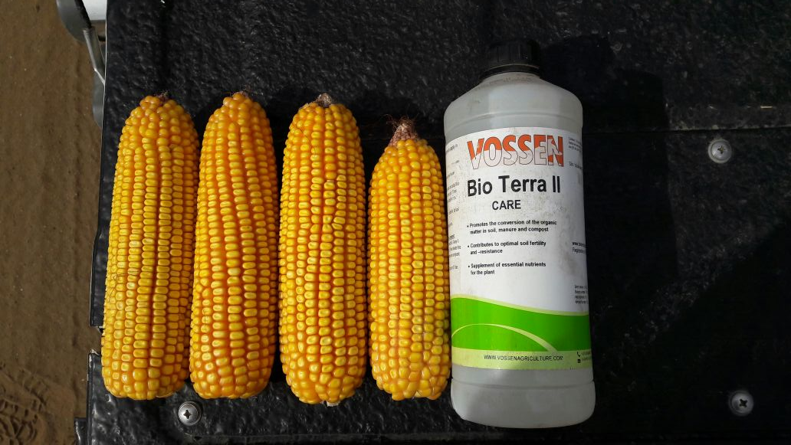
Picture 1: Size comparison of trial cobs.
Picture 2: Size comparison between trial cobs (right) and control cobs (left)
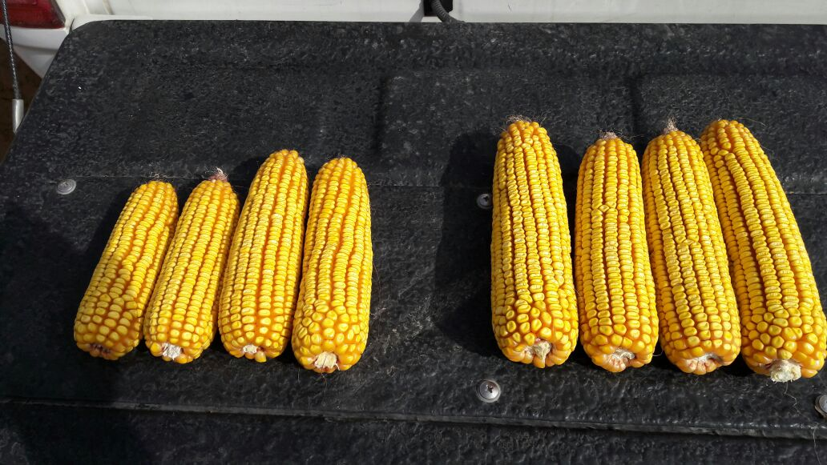

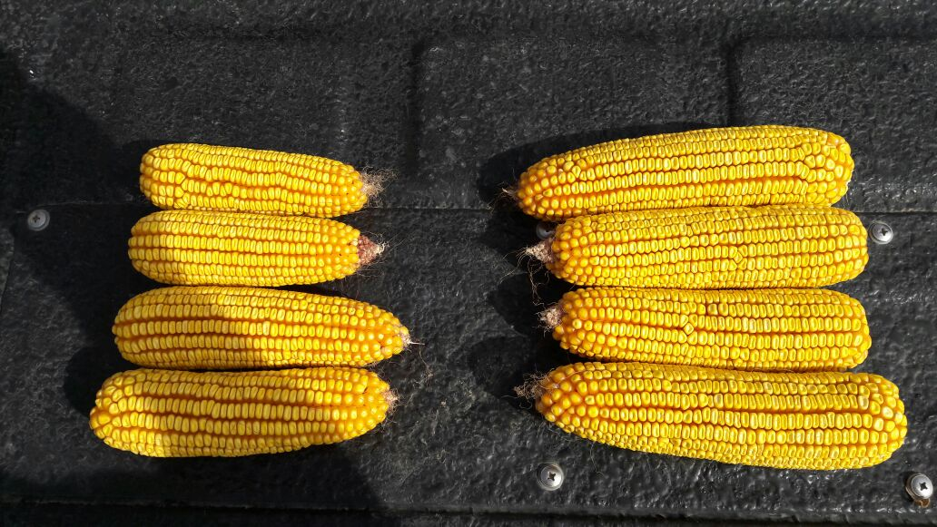
Picture 3: Size comparison between trial cobs (right) and control cobs (left)

